Serial Communication


LAB # 13

Spring 2024
CSE-307L Microprocessor Based System Design Lab

Submitted by: Ali Asghar
Registration No.: 21PWCSE2059
Class Section: C

“On my honor, as student of University of Engineering and Technology, I have neither given nor received unauthorized assistance on this academic work.”

Submitted to:
Dr. Asif Ali Khan

Date:
1st June 2024

Department of Computer Systems Engineering
University of Engineering and Technology, Peshawar

Task:
Code:
Transmitter Code:
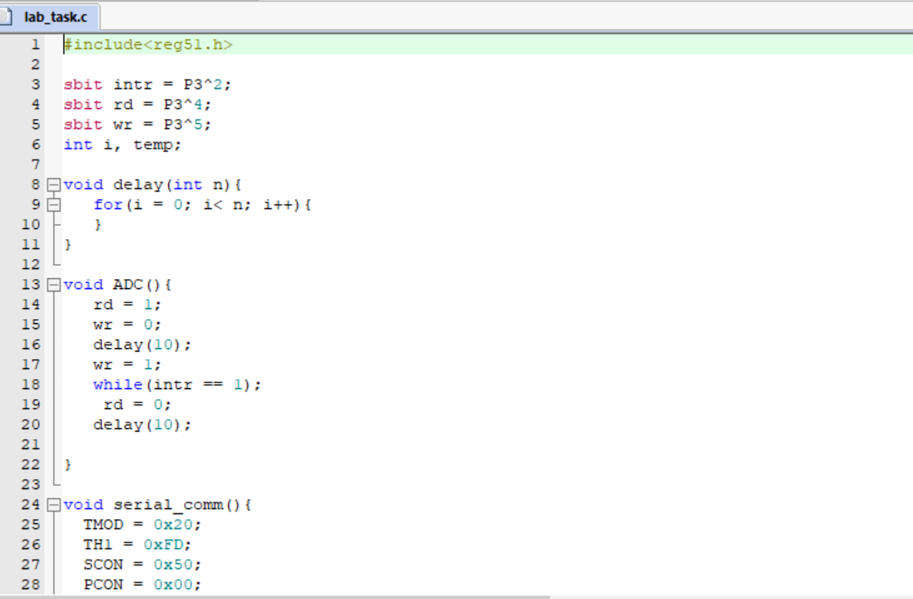
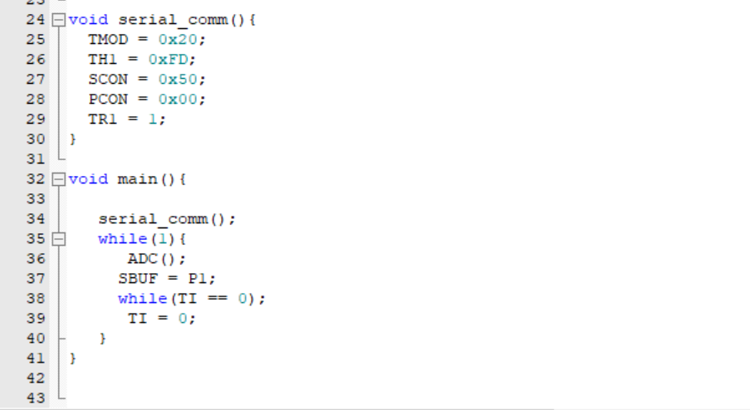

Receiver Code:
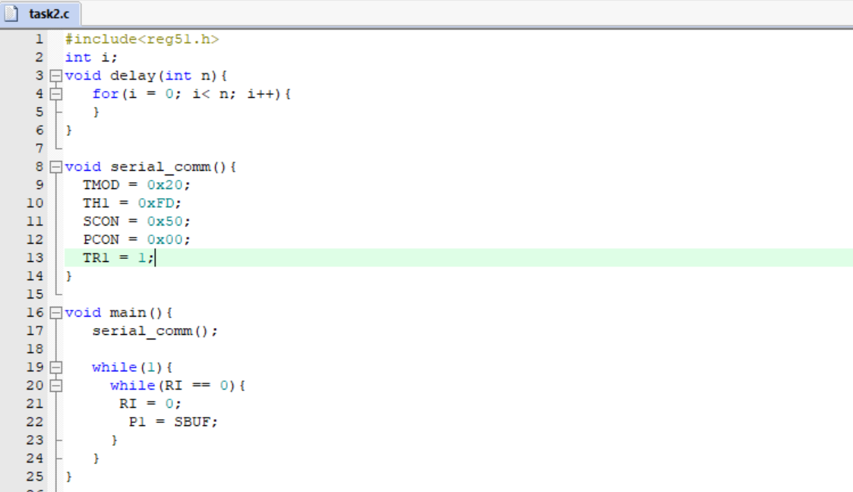

Proteus Simulation:
